Fulbright Foreign LANGUAGE TEACHING ASSISTANT (flta) Program
Instructions for Completing the
2020-2021 Fulbright Foreign Language Teaching Assistant (FLTA) Program Application
Application: https://apply.iie.org/FLTA2020
Read all instructions carefully before completing the application.
Applicants may only apply for one award per application cycle.

Contents
General Information 3
Creating Your Online Account 4
Managing Your Application 6
Country Information 8
Data Privacy 8
Personal Information 8
Contact Information 10
Academic & Professional Information 11
Academic History 11
Employment History 12
Exam Scores 13
Experience Abroad 14
FLTA Information 16
Language Skills 16
Preferences 16
Teaching Experience 17
Academic Interests 18
Plagiarism Agreement 18
Essays and Objectives 19
Additional Information 19
Resume 19
Passport 20
Personal Statement, Degrees, Certificates, or other Supplemental Materials 20
Memberships, Grants, and Awards 20
Outreach Survey 20
Authorization of Release of Information 20
Reference Materials Waiver 21
Recommender Registration 21
Signature 24
Review 24

General Information

The application is supported by all modern browsers. We highly recommend that you use a current version of Google Chrome, which supports Windows, Mac, and Linux platforms.

Prior to starting an application, please complete the following steps:
Step 1: Learn requirements for submitting an application
Before you begin an application, contact the Fulbright Program Office in the country from which you are applying. Deadline dates and application requirements for a Fulbright grant will vary from country to country. You must make sure you are eligible to apply.

Step 2: Record username and password in a safe place
Your email address is your username. When you create an account for this online application, record your password in a secure place. You can log in and out of the application as frequently as you like using your username and password. If necessary, you can reset your password by clicking the “Forgot Your Password” link on the log-in page.

Step 3: Complete the application
You do not need to complete this application at one time. You can re-enter at any time to edit your application. However, once you SUBMIT your application, you CANNOT make changes to it.

To complete your application correctly, please answer all questions completely and carefully. Review these additional tips:
- Use upper and lower-case letters (e.g. John Smith). Avoid using all capital letters (e.g. JOHN SMITH). Do not use special characters, such as accent marks.
- You can copy and paste information into all text boxes.
- Limit your responses to the space provided in all text boxes.
- Prepare required documents and save them in PDF format. It is highly recommended that to preserve any formatting and special characters in your documents, you upload them in PDF format.
- Some questions are “required.” They are marked with an asterisk (*). You will not be able to submit your application until all required items are complete.
- Type out any essays in Word, and then copy and paste them into the application once they are ready.

Step 4: Submit the application
Once you have entered all required information, including recommenders, review your application for errors. You can either navigate back through pages by clicking on the menu bar to the left, or you can review the entire application by downloading the PDF on the “Review and Submit” page. If all information is correct, submit your application. Once you submit you CANNOT make changes to your application.

Creating Your Online Account

- To start, click Create an account.

- Enter your email address, first name, last name, and select your date of birth (Month-Date-Year) from the drop-down menus. Your name must be entered exactly the way it appears (or will appear) on your passport.

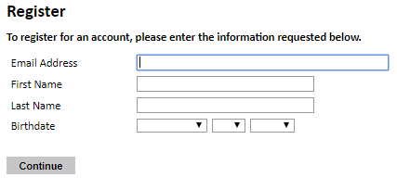
Note: Use an email address that you will be able to access for at least two years after submitting your application. This is the email address you will use to log in to your application account. We recommend you do NOT use a work email address if you will not have access to it during your grant in the U.S.

- Click Continue. You will receive an email from apply@iie.org confirming that you have started the application. The email will include a temporary PIN. Follow the instructions in the email to activate your account using the temporary PIN.

- You will be prompted to enter your pin and then create a password to complete login.

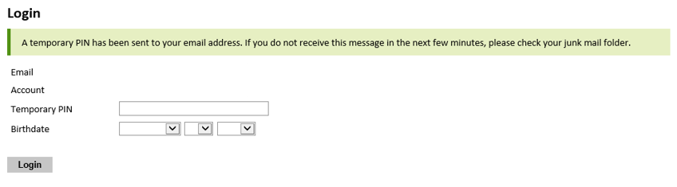

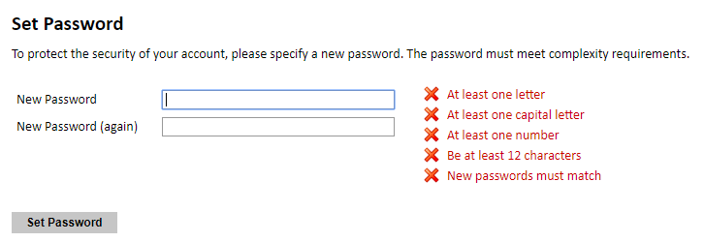

- Returning users: Click Log in and enter your email address and password. If you do not remember your password, click Forgot your password? and follow the resulting instructions.

Managing Your Application

Editing your application prior to submission

- You may log in at any time to review and edit your application form, upload documents, and enter recommender information.
- Remember to save your application after completing each page by pressing the Continue button at the bottom of each page.
Note: The application will automatically log you out after 60 minutes of inactivity, so it is best to save your application frequently.

Reviewing your application after submission
- After you SUBMIT your application, you CANNOT make any changes.
- You may continue to log in to your account to view the information you have submitted, save a PDF of your application form, and manage your recommenders.
- You can manage your recommenders by clicking on the Recommendations section of the online application.

letters of recommendation

- Letters of recommendation will be submitted directly to Fulbright by the recommenders you registered via your application.
- Letters of recommendation and language evaluations may be submitted before or after you submit the application.
- If your recommender is unavailable, you will have the option to exclude the recommender and add an alternative after you submit the application.

Preliminary Questions

These questions address essential program eligibility. All questions are required.

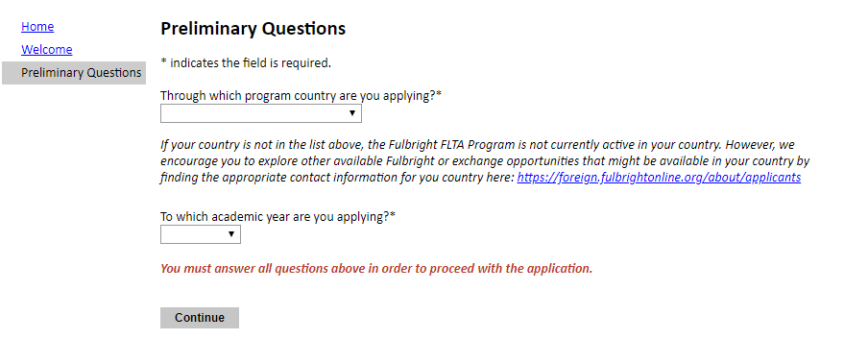

- Select the country through which you are applying for the Fulbright grant from the dropdown menu.

- Select the appropriate program year from the dropdown menu.

- Click Continue to save your responses and advance to the next section.

Country Information

- Review all information in this section!

- Note any country-specific and award-specific instructions for completing the rest of the application, including:

  - Country website
  - Open application cycle
  - Additional required materials

- Click Continue to proceed to the next section.

Data Privacy

- Carefully review the Data Privacy information.

- Click Continue to proceed to the next section.

Personal Information

Enter all required biographical information. Please review country-specific guidance (provided in the Country Information section of the application) to determine whether you must provide additional information.

- Enter your name exactly as it appears on your passport. Only enter a preferred name if it is DIFFERENT than your legal name (e.g. Alex instead of Alexander).

- If your name is recorded differently on any previous records, list it in the Name on Previous Records section (e.g. maiden name).

- The birthdate that you used to create your account will automatically appear. If you entered this date incorrectly during your account creation, you may correct it now.

- Enter your city of birth and select country of birth, sex (as it appears or will appear on your passport or travel document), preferred gender identity, and marital status from the dropdown menus provided. Enter number of dependents and select ‘yes’ or ‘no’ to indicate you understand the FLTA dependent policy.

- Select your country of citizenship and country of residence from the dropdown menus provided.

- If applicable, enter your national identification number and any additional countries in which you hold citizenship.

  - To select multiple countries, hold down the CTRL (PC) or Command (Mac) button when selecting options.

- U.S. Citizenship, Dual Citizenship with the U.S. or Permanent Residency, Visa Diversity Lottery Application: select ‘yes’ or ‘no’ to indicate your response.

  - Applicants cannot be U.S. citizens or permanent residents of the U.S. to participate in the Fulbright Foreign Language Teaching Assistant (FLTA) Program.

- Click Continue to save your responses and advance to the next section.

Contact Information

Enter all required contact information. Please review country-specific guidance to determine whether you must provide additional information.

- Select the country where you live from the dropdown list first when entering your permanent address (i.e. physical address where you live).
  - Based on your country selection, the subsequent fields will change to match the address format of that country.
  - Complete the remaining address fields. Do not use accents or special characters.

- Select ‘yes’ or ‘no’ to indicate if your current mailing address (i.e. the address where you receive mail) is the same as the permanent address you entered above. They do not have to be the same.
  - If you answer ‘no,’ then a second address section will appear where you may enter your mailing address information.
  - If you answer ‘yes’ to this question, proceed immediately to the next question.

- Enter your contact numbers as appropriate. Include the country code. If the field turns red, please review the numbers that you have entered to look for any errors.
  - To find the correct country code, click on the blue ‘country code’ link.

- The email address used to create your account will appear in the primary email address field and will not be editable. You may provide an Alternate/Secondary Email that can be used to contact you if Fulbright Program Officers cannot reach you via your primary email address.
Note: All system-generated emails will continue to go to your primary email address.

- Entering emergency contact information is not required unless directed by the country-specific instructions. If you would like to provide emergency contacts in your home country, please enter the appropriate information. The individuals you list may be contacted in the event of an emergency while you are participating in grant activities, including any required travel for interviews in your home country.
  - When entering the address, choose the country that corresponds to your emergency contacts’ address first and the following fields will update to match the address format of the selected country.

- Click Continue to save your responses and advance to the next section.

Academic & Professional Information

This section collects information about your academic and professional background.

Prepare and upload documents in PDF format as required (*). Note any page limits and ensure your documents do not exceed page limits.

Academic History

- List all post-secondary educational institutions from which you have received a degree or academic credential. You MUST include any education institutions you are currently attending (even if you have not yet completed your educational program) and estimated date of graduation/completion.

  - Click Add Institution.
  - Type in the name of the institution.
  - Select the country where the institution is located from the dropdown menu.
  - Enter the appropriate city and region/state.
  - Select the month and year of start and end dates (Month – Year format) that you attended this institution.
    - If a degree is in progress, list expected end date of academic program.
  - Choose the level of study (graduate or undergraduate) from the dropdown menu.
  - Select the U.S. equivalent of the degree or diploma earned (e.g., BA – bachelor’s degree).
  - Select the date (Month-Year format) that you received your degree from this institution.
    - If a degree is in progress, list expected date of conferral in this field.
  - Enter the discipline in which this degree or diploma was earned (major).

- Use the section below to upload scans of all available transcripts from the post-secondary institution you have attended.

  - Select Choose File and locate the desired file on your computer. Click Open.
  - You may upload transcripts as a multi-page documents or upload single page documents. PDF, JPEC, and TIFF image files are all accepted.
  - Click Save.

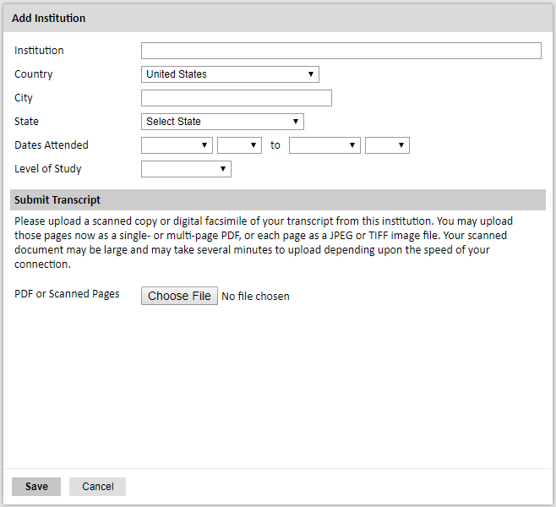

- To add additional entries for post-secondary educational institutions, click Add Institution and follow the bulleted instructions above.

Employment History

- List your current professional affiliation or employer by clicking Add Employer under Organization Name.

  - Enter the name of the organization.
  - Select the country from the dropdown menu, and enter in the city, state/region, post code, and telephone number as applicable.
  - Select the start and end dates for the position you entered (Month-Year format). If you are currently employed in this role, choose “Present” for the end date.
  - Enter your starting position title and ending position title (e.g. Teacher, Administrator, etc.) or type of work (e.g. Social Work).
  - Enter your position description and primary reason for leaving, if applicable.
  - Click Save.

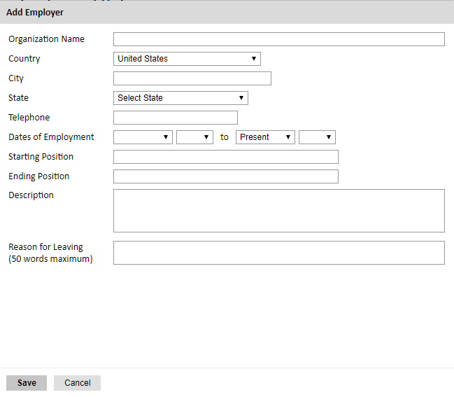

- To add additional entries for employment history, click Add Employer and follow the bulleted instructions above.

Exam Scores

This section collects information about standardized test scores that you have taken or will take in the future. Relevant standardized tests for the Foreign Language Teaching Assistant (FLTA) Program include TOEFL and IELTS. Standardized test scores are often required for admission to U.S. institutions.
- Select Add Test.

- Select the test type from the dropdown menu. If applicable, select the subtype.

- Select the test date from the dropdown menu (Month-Day-Year format).
  - If you have not yet taken the test, enter the date that you are registered for the test.

- Enter your test scores, if you have the results from the test.

- Click Save. Repeat these steps for all applicable standardized tests.

- Click Continue to save your responses and advance to the next section.

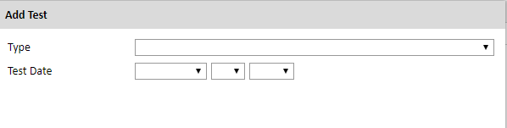

Experience Abroad

- List any travel, study or residency you have had abroad (in any country other than your own) for more than one month. This can include time overseas for education, research, business, vacation, etc.

  - Choose the number of experiences abroad you would like to enter using the dropdown menu. If you no experiences abroad to add, click Continue.
  - Choose the country in which you spent your professional travel and/or residence abroad from the dropdown menu provided.
  - Select the start and end dates (Month-Year format) of you travel/residency.
  - Enter the purpose of your travel abroad.
  - Click Continue.

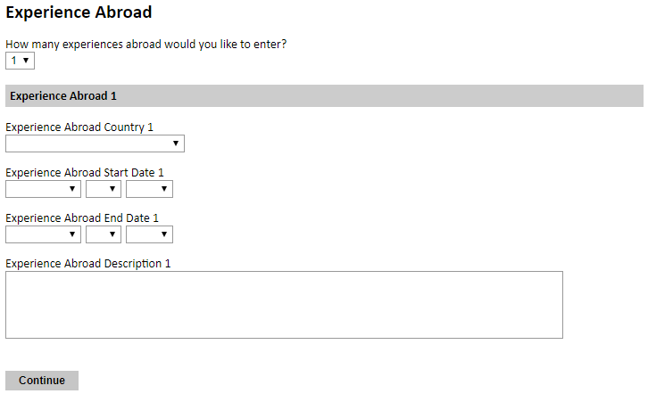

- If you have more than one trip abroad to enter, click select the appropriate number in the first question and follow the bulleted instructions until all entries have been saved.

FLTA Information

This section collects information specific to the Fulbright Foreign Language Teaching Assistant (FLTA) Program. Please review country-specific guidance to determine whether you must provide additional information.

Language Skills

This section collects information about your native language, English language skills, and any additional languages that are relevant to your application.

- Select the language you are applying to teach/assist in the U.S. Rate your language proficiency in Reading, Writing, and Speaking in this language. Select Native, Advanced, Intermediate, Beginner or No Ability from the dropdown menus as appropriate.

- Select your native language from the dropdown menu provided.

- Rate your English language proficiency in Reading, Writing, and Speaking. Select Native, Advanced, Intermediate, Beginner or No Ability from the dropdown menus as appropriate.

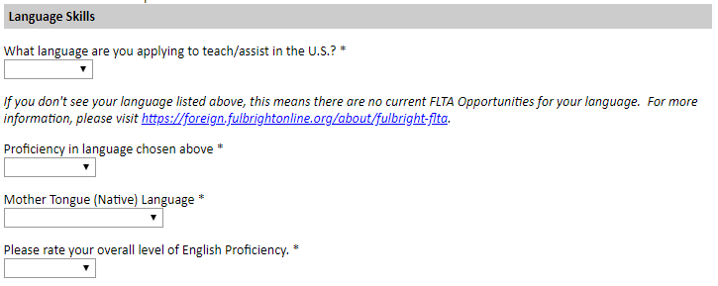

Preferences

- Using the drop-down menu, select which option you are willing to do in your role as a language assistant on a U.S. university campus.

- Indicate if there is a particular region in the U.S. that you would be most interested in.

- Indicate if there is a college or university type which you would most prefer. If you believe you are adaptable, select N/A.

- Indicate if there is a college or university type which you would refuse an offer assistantship. If you believe you are adaptable, select N/A.

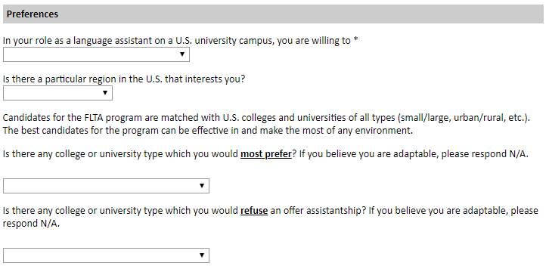

Teaching Experience

- Input the total number of years and months of teaching experience you hold and/or have held in the past.
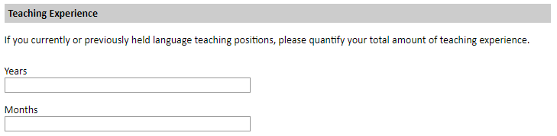

Academic Interests

- Input your academic and non-academic interests into the appropriate text boxes.
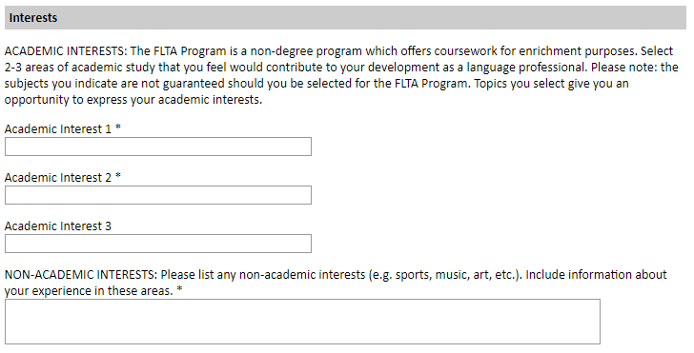
- Click Continue.

Plagiarism Agreement

This section explains the Fulbright Foreign Language Teaching Assistant (FLTA) Program policies regarding plagiarism. Plagiarism in any of your answers to these questions will result in your disqualification from participating in the FLTA program.
  - Review the short video on plagiarism and appropriate citation in the FLTA program application.

  - To indicate your understanding of the policy, select ‘yes’ or ‘no’ as appropriate.

  - Click Continue.

Essays and Objectives

This section collects information about your objectives and motivations for applying for the FLTA program. In addition, you will be required to answer questions regarding your teaching methodologies and techniques, and how you plan to share your culture in the U.S.

- Select Choose File and locate the desired file on your computer. Click Open.

  - Uploaded objective statements are limited to a maximum of two pages. PDF, JPEC, and TIFF image files are all accepted.
  - Click Upload.

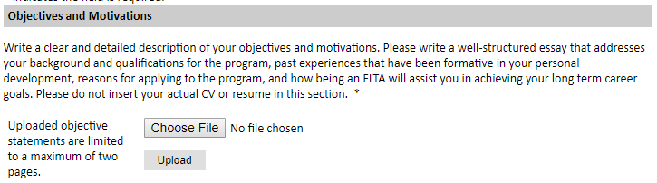

- Using the space provided, input your responses to the essay questions in the large text boxes.

- Click Continue.

Additional Information

Use this section to upload any required or optional additional documentation per your country-specific guidance.

Resume
- Upload your curriculum vitae/resumé in PDF format. This is a required document.

- Click Choose File.
- Locate and select the file that you previously saved to your computer.
- Click Open.
- Click Upload to complete the file upload.

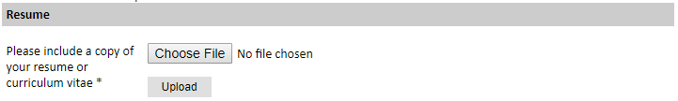

Passport

- Upload a copy of your passport or travel document. This is a required document.

  - Click Choose File.
  - Locate and select the file that you previously saved to your computer.
  - Click Open.
  - Click Upload to complete the file upload.

Personal Statement, Degrees, Certificates, or other Supplemental Materials

- If applicable, upload a copy of your personal statement, degrees, certificates, or other supplemental materials using the instructions above.

Memberships, Grants, and Awards

- Using the space provided, list scholarships, fellowships, academic honors or prizes which you have received.

- If you are pursuing any other scholarship, fellowship, or employment that would supersede your participation in the FLTA program, you are required to explain. Use the space provided to indicate your response.

Outreach Survey

- Complete the Outreach Survey.

- Click Continue to save your responses and advance to the next section.

Authorization of Release of Information

- Select ‘yes’ or ‘no’ to indicate your authorization of release of the information you have provided in this application.

Reference Materials Waiver

- Select ‘yes’ or ‘no’ to indicate whether you waive your right to review the information contained in the evaluations submitted by recommenders on your behalf.

- Click Continue to save your responses and advance to the next section.

Recommender Registration

Use this section to register your recommenders. You are required to submit 3 recommendation letters.

Once you register your recommenders, they will receive an automatic email with instructions on completing the online recommendation form. You can track the status of recommendations, send reminders, and add/delete recommenders through this system before and after submission of your application.

- Click Add Recommender.

- Complete all fields in the pop-up form pictured below.

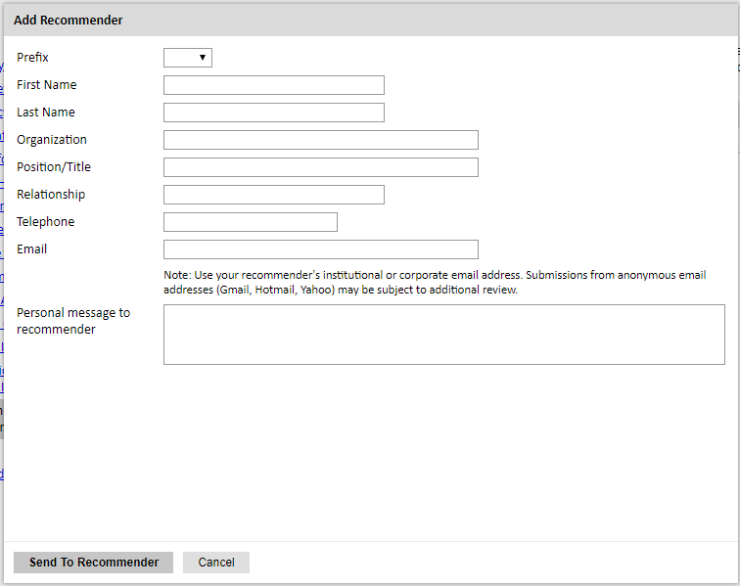

- Click Send to Recommender to generate automatic email to recommender.

- Click Continue to save your responses and advance to the next section.

- Once sent, you will have the option to Edit Recommender information if they have not yet started progress on their response and Save, Send Reminders, and Exclude if you wish to remove the recommender and replace with another individual.

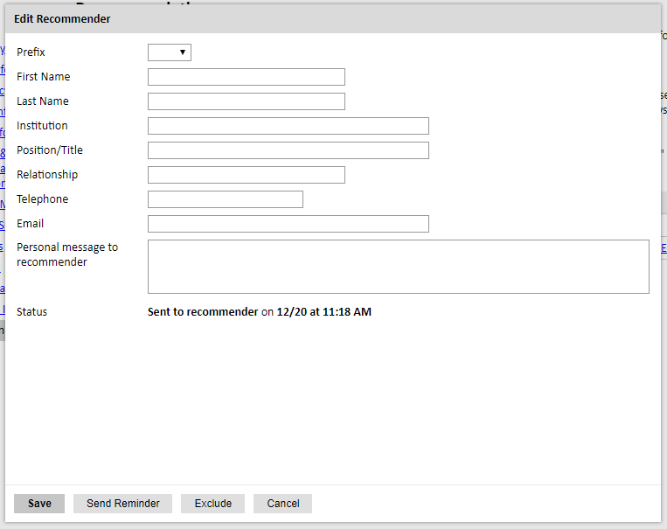

Signature

Certify that the information you provided in the application is true and complete by typing your full legal name in the Signature Box:

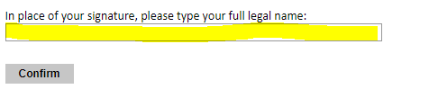

Click Confirm to continue to the next page.

Review

The application will review the responses entered and will display any incomplete questions and required attachments that are missing.
• If no errors appear, then your application is ready for submission.

• If any errors appear, correct or complete these sections and return to the Review section to determine if your application is ready for submission.

REVIEW ALL RESPONSES. CLICK SUBMIT.

